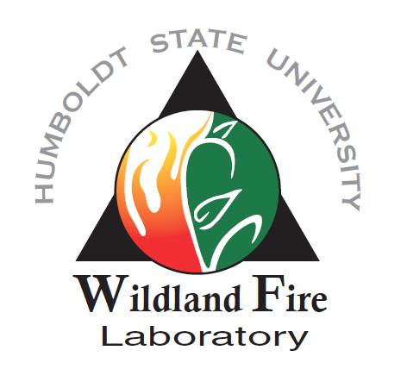
Fire Research Field Assistants (4)

Assist with field data collection for HSU Wildland Fire Lab and USDA Forest Service Pacific Southwest Research Station research on fire effects and fuels management

We are looking for four field assistants to assist the HSU Wildland Fire Lab and USDA Forest Service Pacific Southwest Research Station. Research project topics will vary depending on the position and needs at the time but will likely include the follow: fuel dynamics following prescribed fire and other fuels treatments, fuel treatment effectiveness following wildfire, effects of prescribed fire and/or indigenous burning on forest structure and other ecological outcomes or tribal use qualities. Field research would occur at sites throughout northern California, and entail navigating to plots, collecting a variety of tree and post-fire measurements, and other tasks. Assistants should be able to hike short to moderate distances to research plots, tolerate hot/dry weather conditions, and be willing to tent camp for up to four to eight days at a time. Candidates must have a valid drivers license and complete defensive driver training. Rental cars will be available for work-related travel. We will provide training for specific data collection methods, though experience taking standard forest, fuels, and vegetation measurements is preferred.
Salary and Duration
• $16-$17 per hour (depending on experience) for ~12 weeks (mid-May- mid-August), possibility for extending part-time work into the fall.

Location: Arcata, CA; Orleans, CA; or Redding, CA

Qualifications
Strong candidates for the position will have the following:
• Current student or recent graduate from forestry, fire or related field
• Grade point average of 3.0 or greater on a 4.0 scale
• Previous coursework in Forestry, Fire Management, Ecology, Botany or a related field
• Ability to navigate using maps and GPS
• Prior field work experience outside of the classroom (volunteer or paid)
• Research interest and field experience in forestry, ecology, or related field
• Positive attitude and ability to work well with others in remote field sites for extended periods, often during hot seasonal conditions

HOW TO APPLY
To apply, send (as a PDF or Word Document): 1) a resume (including GPA and complete contact information); 2) a brief letter of interest (clearly state relevant education, experience, and interest in the position); 3) unofficial transcripts, and 4) the names and contact information of three references to Jeff Kane (jkane@humboldt.edu). The position will be open until filled, but review of applications will begin in late February. Incomplete applications may not be considered.

