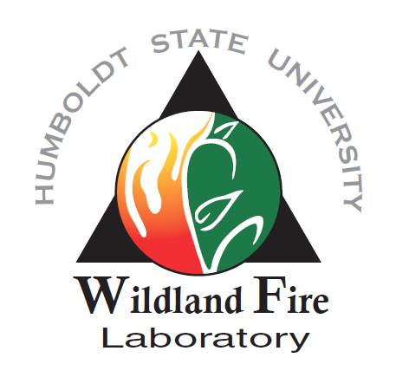
Master’s Degree Assistantship available in Fire and Fuels Management within the Department of Forestry and Wildland Resources, Humboldt State University

Dr. Jeff Kane (https://fwr.humboldt.edu/people/jeffrey-kane) is seeking a highly motivated student interested in joining the HSU Wildland Fire Lab (https://firelab.humboldt.edu/) to pursue an MS degree in Forestry and Wildland Resources at Humboldt State University
(http://humboldt.edu/fwr/program/graduate_degrees). The selected student will collect and analyze field and lab data to examine fuel changes with time since treatment (thinning and prescribed fire) in the Klamath Mountains of California. Duties will include collecting field observations on tree and fuel characteristics and collecting fuel samples. Laboratory work will include processing samples to characterize fuel accumulations, fire behavior and effects modeling, and statistical analysis. The selected student must be able to work well independently and in team settings, tolerate adverse field conditions, assist with other on-going projects, and be willing to camp for extended periods of time during the field season. In most cases students will be based out of Arcata, California but will travel to field sites and typically work four 10 hour days each week during the summer.

Minimum Qualifications:
Strong candidates for admission to the HSU Department of Forestry and Wildland Resources Graduate Program should have a grade point average of 3.0 or greater on a 4.0 scale for all college and university work, and GRE scores in the top 50th percentile (>152 Verbal, >153 Quantitative, >4 Writing). There is some flexibility if the candidate has a strong background related to the research topic and associated methodologies. Minimum qualifications include a BS degree completed no later than June 2020 in Forestry, Forest Ecology, Ecology, or related fields.

Additional minimum qualifications include:

● Undergraduate coursework in some combination of forest ecology, fire ecology, and fire science/management.
● Prior field work experience with basic tree measurements and fuels sampling
● Orienteering skills (navigation with map, compass, gps, and aerial photographs)
● Ability to navigate off trail and hike up to six miles per day in steep terrain.
● Prior work or educational experience processing any type of soil or fuel samples in a laboratory setting
● Competent using Microsoft Word and Excel
● Possess a valid US driver’s license

Preferred Qualifications:

● Prior field experience with fire and fuels sampling
● Experience collecting and analyzing data
● Experience in fire behavior and effects modeling
● Undergraduate coursework in statistics using R software

Assistantship Benefits

MS student will be hired as a full-time field research assistant beginning in mid-May/early June 2022 at $20,000/yr. The project has funding for at least 2 years, with the second year of funding conditional based on student academic standing and project progress. Student will possibly be required to teach 1-2 lab sections of an Introduction to Wildland Fire course. MS student will supervise at least one undergraduate field assistant supporting field data collection and laboratory sample processing.

How to Apply

Successful applicants would begin field work in summer 2022 and enroll in graduate school fall semester of 2022. Review of applications will begin in mid-February. To apply, send the following (as a single PDF document) to Dr. Jeff Kane (jkane@humboldt.edu):

1. A letter of interest (clearly stating your background, research and career interests).
2. CV (including GPA, GRE scores, prior relevant work experience).
3. Unofficial transcripts
4. The names and contact information for three academic and/or professional references

